**COVID-19 Test: What to expect?**

**About the test**

* Medical professionals will be administering a nasal swab test.
* This test detects if you currently have the virus. It does not test for immunity or antibodies.
* If your test is negative, you must remain cautious.  You can still get infected.

**Test Site Location**

**SODO Site**

**Address:** [3820 6th Ave South, Seattle WA 98108](https://goo.gl/maps/PJQhkbssJaxgE9yz9)

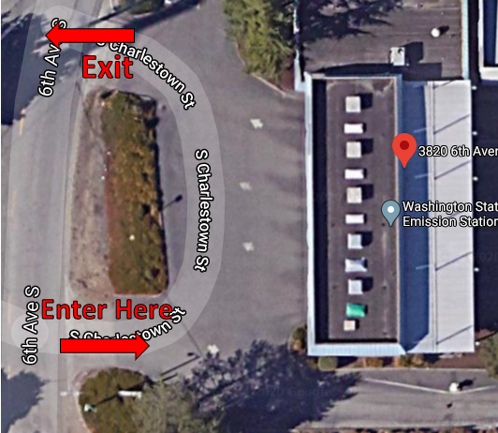

***Satellite Image of SODO Site***

**The “enter” arrow needs to indicate that they drive around the back of the building. Will also have cones and a PEO there during testing.**

**Aurora Site**

**Address:** [12040 Aurora Ave N, Seattle WA 98133](https://goo.gl/maps/HZkcfNbaxKDkxgUd7)

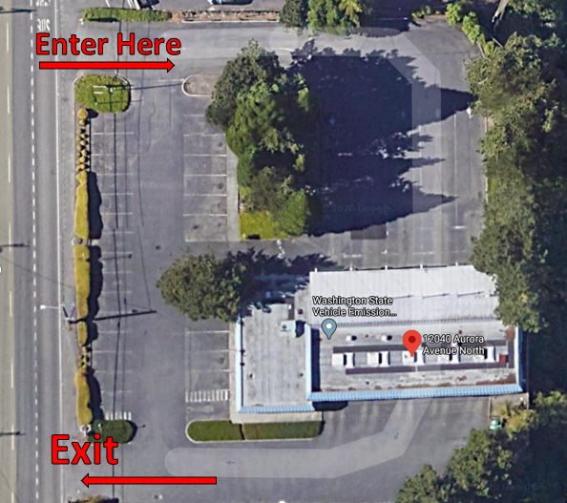

***Satellite Image of Aurora Site***

**The “enter” arrow here should also orient that they will drive through to that holding area.**

**Day of Testing Process**

* Go to your test at your scheduled time. Bring a photo ID with your date of birth and your insurance card if applicable.
* Wear a mask.
* The process will take about 20 minutes.
* If you feel seriously (is “seriously” the right word? Maybe “severely”? Just wonder how most people will interpret this )ill, please do not come to your test. Seek care with your medical provider.
* **If arriving in vehicle:**
* If you arrive at the site in a car, keep your windows rolled up.
* With your window up, you will be asked to show an attendant your photo ID and check in.
* You will then go to a second station for the sample collection process.
* At the sample collection station, you will turn off your vehicle, roll your window down, and verify your name and date of birth. Not positive we have to verify name and dob a second time. I think name only. Need to double check with Patrick and the UW team.
* **If on foot, bicycle, scooter or other transport:**
* Wear a mask and stay 6 feet away from others.
* Follow the attendant’s signs. You will be asked to show your photo ID and insurance card if able.
* You will then go to a second station for the sample collection process.
* At the sample collection station, verify your name and date of birth. Follow the attendant’s instructions.same as above

**How we will collect your sample**

* To take your sample, the medical staff will ask you to tilt your head back 70 degrees oddly specific angle!. They will insert the swab deep into one of your nostrils to collect the sample. It will be held in place and then rotated to collect the sample.
* The staff will then pack your sample for processing.
* Then they will hand you a form with your QR code on it.

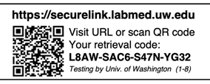

* Please keep this QR code secure. You will need it to get your test results. We recommend that you take a picture of your barcode card in case you lose it.

**How to get your test results**

**Get your results**

* 1. Scan the QR code to access results directly.
  2. 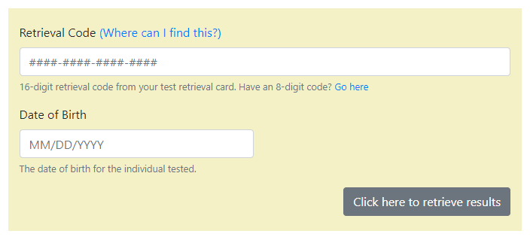Visit the website <https://securelink.labmed.uw.edu> to search your result with the 16-digit retrieval code and your date of birth on the page.
  3. The code will allow you to view your results at securelink.labmed.uw.edu. You will not receive a notification when your result is ready, but you can visit the site as often as you wish to check for the result.

**Test Result Guidance/Stay home either wayThis seems kind of clunky. Maybe just “stay home while you are sick!”**

If You Test Positive – This means you have COVID-19:

* Avoid people who have not tested positive for COVID-19
* You do NOT need to avoid the people in your house who have already been diagnosed with COVID-19.
* Stay in isolation, following the guidance in this document.

|  |  |
| --- | --- |
| How long you stay in isolation depends on your symptoms: If you have no symptoms, stay in isolation for:   * • At least 10 days after you tested. * • **AND** limit contact with others, wear a mask or face covering, and continue to stay 6 feet away from others for another 3 days. | If you have or develop symptoms, stay in isolation for:   * • At least 10 days after symptoms first appeared * • **AND** wait until you have not had a fever for at least 3 days (72 hours) without the use of medicine that reduces fever, such as Tylenol or ibuprofen * • **AND** your cough and breathing are improved. |

**Negative test**

* If you test negative for COVID-19, you probably were not infected at the time of your test. That does not mean you will not get sick. It is possible that you were very early in your infection when you were tested. You could also be exposed after your test.
* Please continue to practice social distancing, wear a mask in public and follow the Stay at Home order.

**Positive result**

Most cases can be cared for at home.

* Do not go to the hospital to seek care unless you have a medical emergency.
* Do not go to work and begin home isolation.
* Continue to monitor your symptoms

**How long you stay in isolation depends on your symptoms:**

|  |  |
| --- | --- |
| How long you stay in isolation depends on your symptoms: If you have no symptoms, stay in isolation for:   * At least 10 days after you tested. * **AND** limit contact with others, wear a mask or face covering, and continue to stay 6 feet away from others for another 3 days. | If you have or develop symptoms, stay in isolation for:   * At least 10 days after symptoms first appeared * **AND** wait until you have not had a fever for at least 3 days (72 hours) without the use of medicine that reduces fever, such as Tylenol or ibuprofen * **AND** your cough and breathing are improved. |

[CDC resources about what to do if you are sick](https://www.cdc.gov/coronavirus/2019-ncov/if-you-are-sick/index.html)